 | 763 Ridge Road  Angier, NC 27501  Tel 919 894 7976 | Date: 07/20/17

Tank Washer For Sale … … … $12,500.00

Equipment Specifications:

Manufacturer Fowler  Model 10 Station  Serial Number 1991 Mfg.  Est. Weight 2,500 LBS  Location South Carolina  Length 108 IN (+ -)  Width 66 IN (+ -)  Height 84 IN (+ -)  Voltage 115 VOLTS  Frequency 60 HERTZ  Phase 1  Current 15 Amps  Notes Washer will have all Stainless Steel “General Beverage” Ball Lock Carriers Installed & Gas Burner. We also can supply a Stainless Steel Vent Stack | 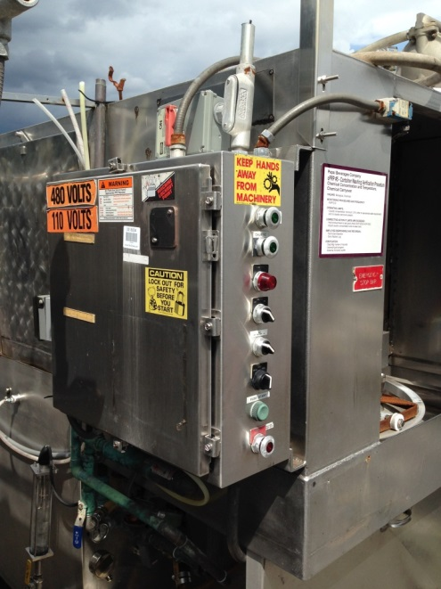
We will prep and load your truck …  30 Day Return Policy Less Freight  We Can Reinstall  Freight Quote Upon Request  We have a complete line of New & Used Premix Equipment Available  Tank Washers & Parts, Carbo Mixers, Mixing Tanks, Stainless Steel Pallet Conveyors, Filling Manifolds, Single Head Tank Filler; Ball Lock & Pin Lock Fittings, “O” Rings, Poppet Valves, Tank Lids, Pressure Relief Valves and Rebuild Kits  We also have New and Used Premix Tanks  Washer … … … $12,500.00  Skidding and Loading Charge … … … $ 500.00  Total Cost … … … $13,000.00 | 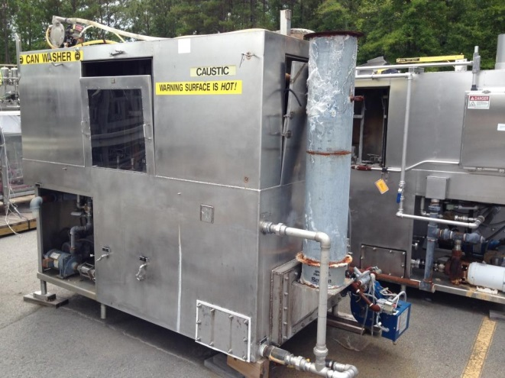

Cardinal BevPack LLC  “Serving the Beverage Industry Since1993”  For Complete Equipment Inventory go to …  Tim Langdon Tim@CardinalBevPack.com  Contact by Cell 919 412 2155 | We offer a complete line of services for a “turnkey” solution including …  * Buy, Sell and Appraisal of Surplus Assets  * Complete Rigging and Millwright Services  * Equipment Location – “You need it, we’ll find it” …  * Inspection, Crating/Skidding, Loading and Shipping Services  * Over 30 years of Experience in Beverage Plants  * Professional: All work areas Neat, Clean, Plumb and Square

Additional Pictures Below

 | 763 Ridge Road  Angier, NC 27501  Tel 919 894 7976 | Date: 07/20/17

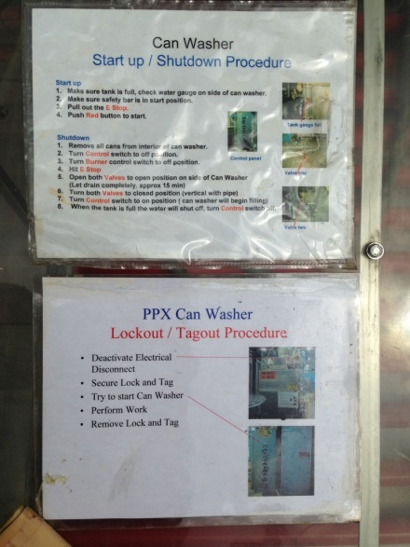 | 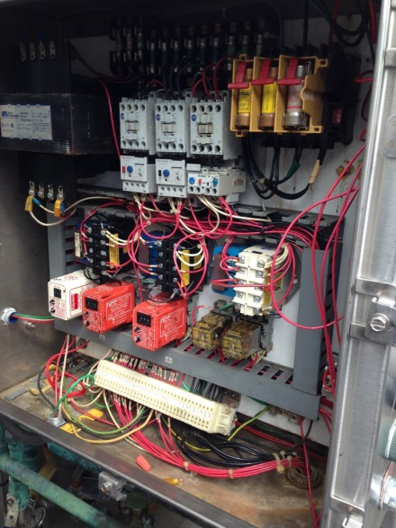 | 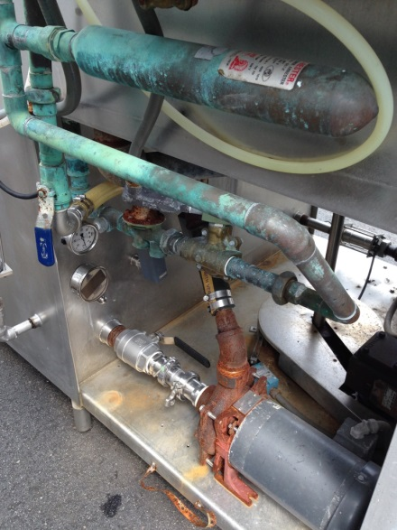
For cleaning 5 Gallon Stainless Steel “Corney” Kegs …  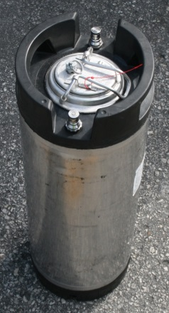  We will replace existing non stainless carriers with Stainless Steel “Pepsi” Ball Lock Carriers  For Additional Charge | 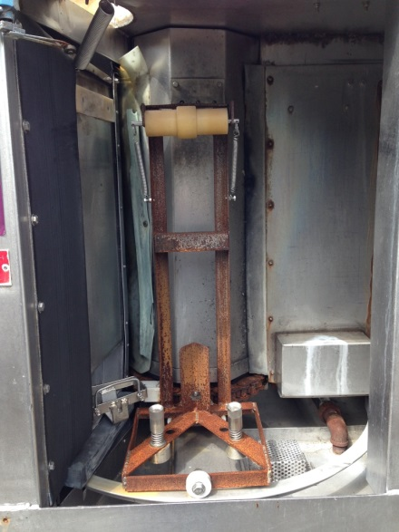  Existing Non Stainless Carriers | 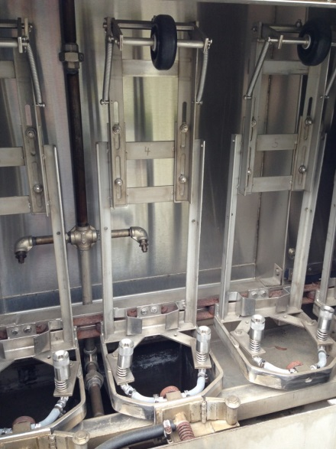  Replacement or Similar SS Carriers
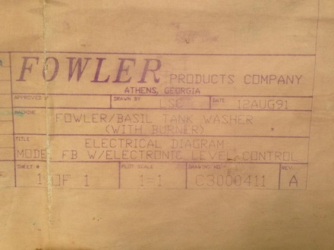 | 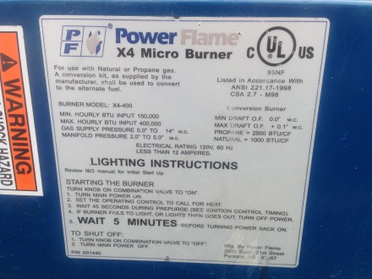 | 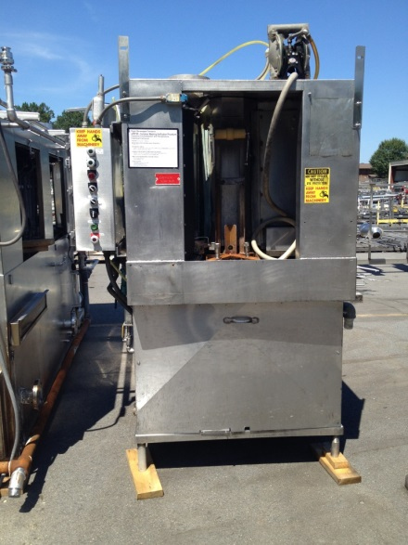

To be removed from our distribution list, please reply and type "Please Remove" in Subject Line

