 | 763 Ridge Road  Angier, NC 27501  Tim Langdon  919 412 2155 cell  Fall 2015 * Page 1 of 4

Item Picture | Item Description | # Pcs / Price
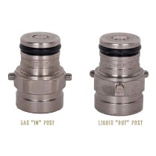 | Used Firestone Pin Lock  Gas & Product Post | (150 Pair)
  Used 300 pcs | $7.50 pair
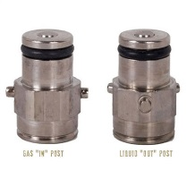 | Used Cornelius Pin Lock  Gas & Product Post | (150 Pair)
  Used 300 pcs | $7.50 pair
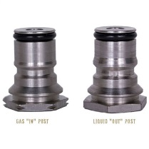 | Firestone Ball Lock  Gas & Product Post  15E04-204 | (50 Pair)
  Used 100 pcs | $9.50 each
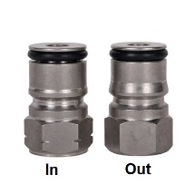 | Cornelius Ball Lock  Gas & Product Post  15E04-204B | (50 Pair)
  Used 100 pcs | $9.50 each
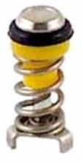 | New * 15C07-105  Poppet Valve For Cornelius Tanks  Fits both Cornelius Ball Lock and Pin Lock Tank Plugs
  689 pcs | $3.75 each
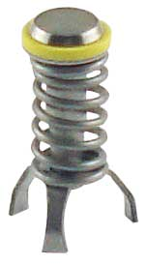 | New * 15E04-228  Poppet Valve For Pin Lock Tank Plugs  Fits old style Firestone or John Wood pin lock tank plugs
  600 pcs | $2.83 each
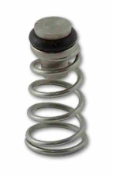 | 15G04-200  Universal Poppet  Fits most common tanks.
  100 pcs | $2.29 each
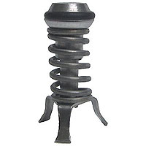
  100 pcs | $0.00 each

763 Ridge Road
Angier, NC 27501
Tim Langdon
919 412 2155 cell

Fall 2015 * Page 2 of 4

Item Picture | Item Description | # Pieces / Price
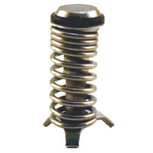 | New * 15E04-227
  50 pcs | $2.70 each
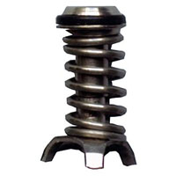 | New * 15E04-272
  98 pcs | $2.70 each
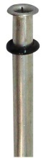 | 15E02-102  Dip Tube O-ring  For Firestone Pin Lock Tanks
  2000 pcs | $0.15 each
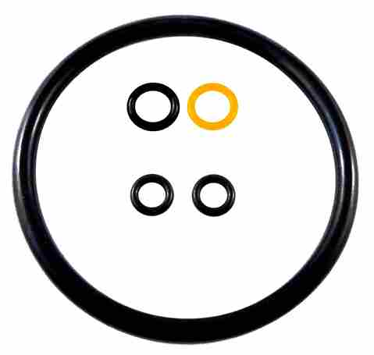 | 15D03-006  Pin Lock Product Tank O-ring Kit  Fits all brands of Pin Lock tanks
  1,000 pcs | $2.50 each
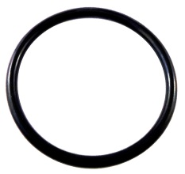 | 15E02-103  Product Tank Closure O-ring  (Universal)
  1173 pcs | $1.59 each
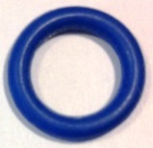 | Light Blue General Beverage  Dark Blue General Beverage
  361 pcs | $14.50  /hundred
  61 pcs | $14.50  /hundred
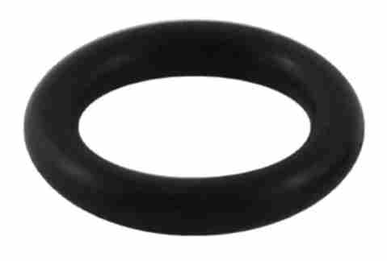 | 15H06-300  O-ring, Standard (pin)(blk)
  1,000 pcs | $14.50  /hundred
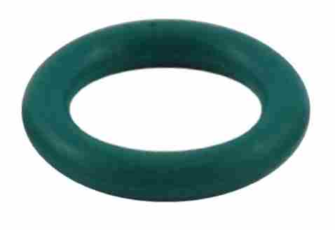 | New * 15H06-302  O-ring, Standard (pin)(grn)
  2000 pcs | $14.50  /hundred
  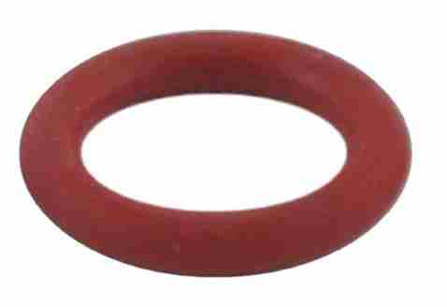
  Item # 15H06-303
  O-ring, Standard (pin)(red)
  1,000 pcs | $14.50  /hundred
  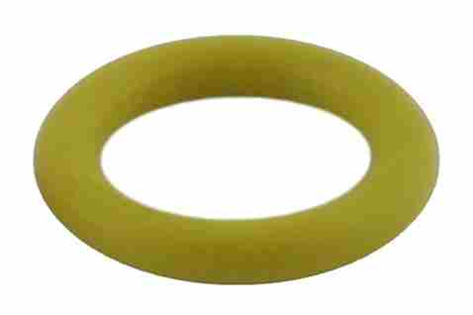
  Item # 15H06-304
  O-ring, Standard (pin)(ylw)
  1,000 pcs | $14.50  /hundred

763 Ridge Road
Angier, NC 27501
Tim Langdon
919 412 2155 cell

Fall 2015 * Page 3 of 4

Item Picture | Item Description | # Pieces / Price
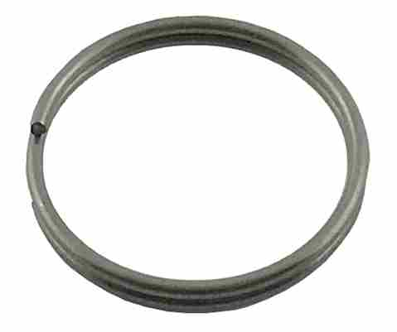 | 15C07-099  Replacement Pull Ring For Aeb Manual Relief Valve
  100 pcs | $0.75 each
No Picture | Ball Lock Gas Plugs
  243 pcs | $0.25 each
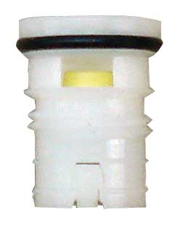 | New * 15C07-109  Pre-set Relief Valve  For Cornelius/Firestone Pin Lock Tanks  For Standard Coke Lids?
  500 pcs | $4.29 each
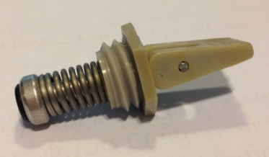 | General Beverage Replacement Relief “Flipper” Vlaves
  Used 24 pcs | $2.00 each
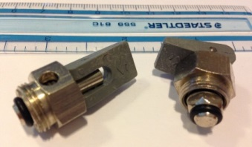 | Relief Valves
  Used 15 pcs | $2.00 each
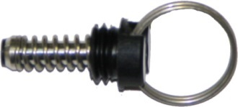 | New * 15C07-103  Relief Valve for Pull Ring Lid
  115 pcs | $2.75 each
  Used 13 pcs | $1.00 each
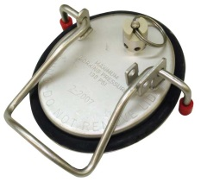 | Used Pull Ring Lids
  Used 100 pcs | $10.00 each
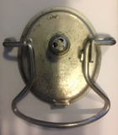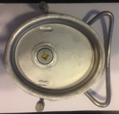 | Used Standard Coke Lids
  Used 800 pcs | $ 7.50 each
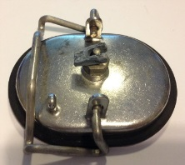 | Used Race Track Lids
  Used 30 pcs | $12.00 each

763 Ridge Road
Angier, NC 27501
Tim Langdon
919 412 2155 cell

Fall 2015 * Page 4 of 4

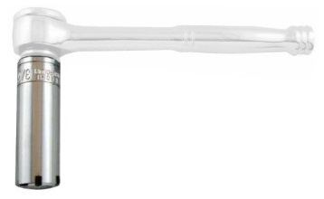 | New * 15E04-205  Pin Lock Plug Socket  Special socket designed for quick and easy removal / installation of pin lock plugs. 3/8" Drive Socket Ratchet Not Included.
  3 pcs | $15.95 each
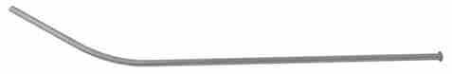 | Used Product Tubes  For both Coke & Pepsi Tanks  Specify Tank when ordering.
  Used 500 pcs | $2.00 each
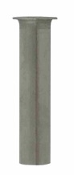
  Used 500 pcs | $1.00 each
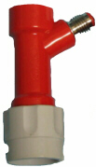 | Plastic Liquid Dispenser Tap  3/16” Tubing  Pin Lock
  1 pcs | Call
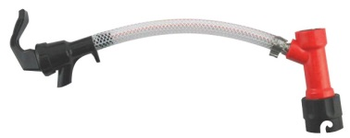 | Pin Lock Hookups
  3 pcs | Call
 | Ball Lock Hookups
  3 pcs | Call

